Name___________________________________

Quick Quiz

**Unit Rate 15**

Identify the unit rate:

1. $78 for 3 pizzas 2. $y=10x$

**$_________ per pizza unit rate =_________**

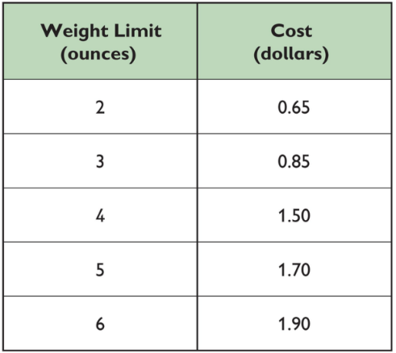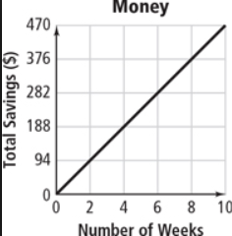3. 4.

**$ ________ $_______**

**per ounce per week**

____________________________________________________________________________

Corrections

**Unit Rate 15**

Identify the unit rate:

1. $78 for 3 pizzas 2.

**$_________ per pizza unit rate =_________**

3. 4.

**$ ________ $_______**

**per ounce per week**